Iran 1979: the Islamic revolution that shook the world
by D. Parvaz
11 Feb 2014
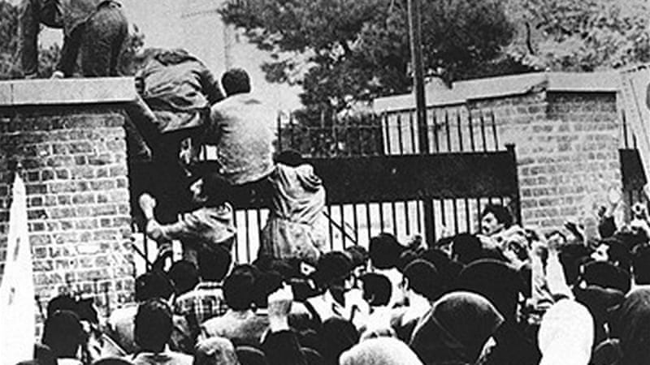

The storming of the US Embassy in Iran in 1979 was the start of decades of enmity between the two countries [EPA]
The Middle East and North Africa continue to roil in the aftermath of popular uprisings - revolutions that continue to shape Libya, Tunisia and Egypt after the fall of the strongmen running the show.
How the autocratic/theocratic dust settles remains to be seen, but the one revolution in the region that signalled an indisputable sea change was Iran's 1979 Islamic Revolution, whose 35th anniversary will be celebrated on February 11.
Just how major was the impact of the revolution that saw the ouster of Iran's king, Shah Mohammad Reza Pahlavi, and the instalment of Ayatollah Ruhollah Khomeini as the supreme leader of the Islamic Republic?
To start with, anyone puzzling over the close relationship between Hezbollah and the Syrian regime needs to look no further than Iran and its role in that arena over the past decades.
"The emergence of Hezbollah in Lebanon, the moral boost provided to Shia forces in Iraq, the regional cold war against Saudi Arabia and Israel, lending an Islamic flavour to the anti-imperialist, anti-American sentiment in the Middle East, and inadvertently widening the Sunni-Shia cleavage, are for me the most important by-products of the Iranian revolution," said Mehrzad Boroujerdi, professor of political science at Syracuse University, when asked for the top five geopolitical events set off by the Iranian revolution.
Regional heavyweight is born
Aside from ridding the country of the monarchy, Iran's revolution also set off a series of events that triggered several conflicts in the region, starting with Iraq's attack on Iran.
"Everything played itself out. There was no way that the spirit of the revolution would have fizzled out inside Iran nor the eagerness of the people for revolutionary change could have been dampened," said Haleh Esfandiari director of the Woodrow Wilson Middle East Program in Washington, DC.
"But then there was Saddam Hussein's invasion of Iran in 1980, which, ironically, strengthened the revolution and fed Iranians the determination to carry the revolution outside Iran's borders," said Esfandiari.
With time, the Islamic Republic's influence reached far and wide.
"Iran's creation of Hezbollah in Lebanon altered Lebanese politics forever, and opened a second front against Israeli ambitions, which had not been imagined," said New-York-based journalist Hooman Majd.
"So undoubtedly Iran has gained influence and strength, and as a nation with an ideology independent of East and West, has to now be considered in any Middle Eastern issues. That in itself is a change in global geopolitics, where before the fall of communism you had an East-versus-West scenario everywhere, including the Middle East, with players lining up on either side, and now you have Iran in the mix."
Had the revolution not taken place, "We'd be looking at a different Middle East," said Gary Sick, former National Security Council analyst on Iran and a professor at Columbia University's School of International and Public Affairs.
"Basically, the Iranian revolution was an enormous shock to the system, especially in the Persian Gulf… The fact that you had this power coming in with really revolutionary objectives, including an objective to try and overthrow the monarchies - they don't talk about that any more - that scared them to death," said Sick.
That fear set in motion conflicts and alliances that, 35 years later, still shape the region.
For example, Iraq's attack on Iran not only rallied the population around Khomeini, but also served to galvanise a network of those who opposed the Islamic Republic.
"And the Arab world's support of Saddam all the way through, and Saddam's attack, and the spread of that war through the Persian Gulf, and the oil lines in particular, gradually drew the United States into the Middle East," added Sick.
And this too had its consequences: It invited the US as a major military force into the region.
New geopolitical chessboard
Even to those who weren't tracking regional changes, the hostage crisis - where revolutionaries took 52 Americans hostage for 444 days in the barricaded US embassy in Tehran - signalled the start of major hostilities between the US, its allies, and Iran, resulting in, among other things, decades of sanctions.
"It is fair to say that Washington was beginning to get worried about the anti-status-quo messages of the Iranian revolution even before the hostages were taken, but the hostage crisis was a game-changer," said Boroujerdi.
The sanctions that for decades jeopardised Iran's economy and wreaked havoc with the world's oil markets can be traced to the hostage crisis.
"The American political class has never recovered from the shock and humiliation of the hostage crisis. It cast Iran as the face of evil in many American hearts," said journalist Stephen Kinzer, author of several books on US-Middle East relations.
"This anger is the main reason why the US has been so unrelentingly hostile to Iran over three decades," said Kinzer.
Beyond the anger and humiliation, Majd said one of the seismic results of the Iranian revolution was that it forced the US into building a military presence in the region.
"Up until the Iranian revolution, the United States had been very reluctant, under [President] Jimmy Carter, to create a base in the Middle East... The revolution changed their calculus," said Majd.
And how.
The US had almost no military presence in the Gulf area until about 1986. Now it has a base in almost every country in the region.
"[Increased US military presence] started with the Iran-Iraq war, and stepped up when Saddam Hussein made the incredibly stupid mistake to invade Kuwait in 1989, and that drew the United States in a major way and we never stopped maintaining our presence there," said Sick.
The US troops he drew into the region, said Sick, ultimately played a role when the US decided to invade Iraq in 2003.
"The irony, in turn, is that the United States invasion of Iraq and Afghanistan eliminated Iran's two biggest rivals in the region [the Taliban and Saddam Hussein] and left Iran as the most important player, which is why the Arabs are so scared. And yeah, all that started with the revolution."
Arab Spring legacy?
So far, there is no indication that any of the uprisings in the Arab countries will follow the Iranian model, even though, as Boroujerdi puts its, "The lasting impact of the Iranian revolution was the empowerment of Islamic groups which could now begin to envision themselves as rulers, rather than merely the opposition."
Esfandiari rejects any assertion that Iran has become a model for other revolutions in the region.
"What Iran did was give a lot of inspiration to the people on the streets for three decades before the Arab Spring started… because the Islamic Republic stood up to the United States and stood up to Israel, and doesn't shy away from expressing its views, over the years, on Saudi Arabia, on Jordan, on the Persian Gulf countries," she told Al Jazeera.
But things changed after the Iranian government's harsh crackdowns on the opposition Green Movement in wake of the disputed 2009 presidential elections , which saw Mahmoud Ahmadinejad take his second term in office.
"I think after 2009, this changed among the people. I think the people in the region who watched the brutal suppression on the streets of Iran were taken aback and changed their minds.
"After that, nobody wanted to imitate Iran."
From revolution to 'evolution'
Looking at the ever-shifting sands in Iran, it is only logical to wonder if the constant struggle to define the Islamic Republic means what started decades ago is still rolling towards either a more moderate or conservative state.
"No, I don't believe this revolution is yet complete. The formation of a theocracy was both novel and anachronistic, and it will take more time for its ramifications to play themselves out," said Boroujerdi.
"The revolution has upgraded the level of political sophistication of the citizenry and it has given birth to new institutions that are still in their early stages. Iranian politics has become 'real' as a result of the revolution and this permanency has become the new 'normal', which we need to get used to," he added.
Sick said Iran's revolution is unusual in that it has gone from a revolution to an evolution - "that is, from ultra-radical positions that they took in the first two, three or four years to a much more moderate, pragmatic position. With this recent agreement on the nuclear issue... this is their effort to become a normal country that actually participates in the world", said Sick.
"But look... revolutions take a long time. They change things, they throw things up in the air - and then things begin to settle and you never know how it's going to settle and how things will work themselves out."
Parvaz, D.: 2014. The 1979 Iran Revolution. Al Jazeera. http://www.aljazeera.com/indepth/features/2014/01/iran-1979-revolution-shook-world-2014121134227652609.html, last updated February 11, 2014.

1979 Revolution: Black Friday
Reza sits, hands bound, in a dingy interrogation room. A single overhead light illuminates his face, bruised and bloodied by the soldiers who raided his safe house. On the table in front of him sits a tape recorder and a folder whose contents may condemn him — and those he loves — to die.
A man with a gravelly voice, the only other person in the room, offers Reza a cup of tea, but it feels less like an offer than a threat. "Your tea is getting cold," the man says almost as soon as he places it on the table.
Will Reza drink from the cup, or knock it to the floor in defiance?
The choice is yours. It's one of many decisions players are forced to make in 1979 Revolution: Black Friday, a new video game that puts players in the middle of the Iranian Revolution. Using actual events, people, and places, the game presents an opportunity to explore and experience the complex forces that drove the revolution, which resulted in the overthrow of US-backed Shah Mohammed Reza Pahlavi and the rise to power of Ayatollah Khomeini in the new Islamic Republic.
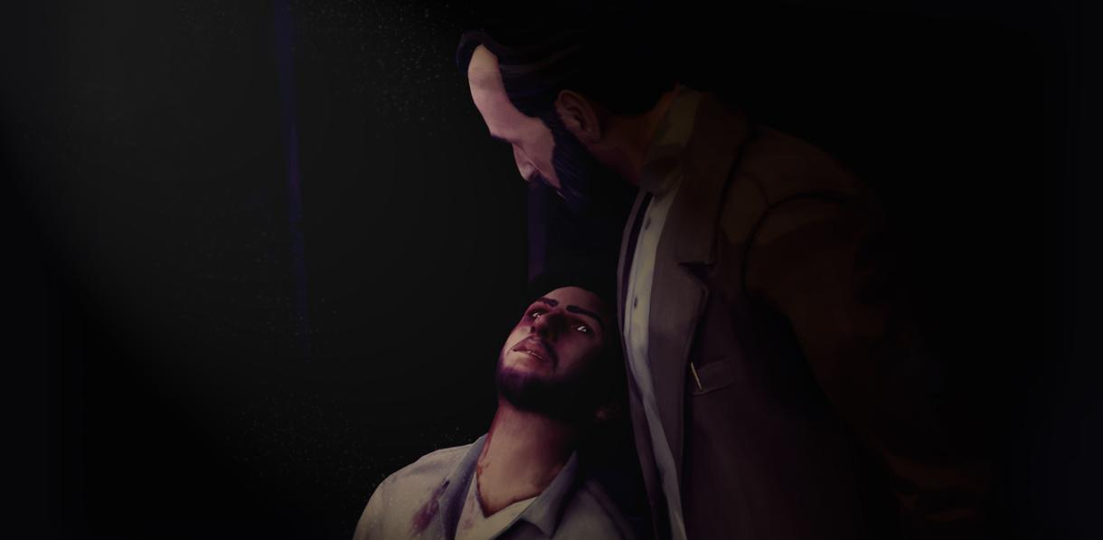
Players take on the persona of Reza Shirazi, an aspiring photojournalist who gets swept up in the unfolding revolution in September 1978. From the day when he first photographs protesters from a Tehran rooftop until he finds himself imprisoned in 1980, players must make choices that affect the way the story plays out as the game progresses. Do you drink the tea? Your decision will have consequences.
The interrogation is set in Iran's notorious Evin Prison, long known for holding political prisoners. (Recently, Jason Rezaian of the Washington Post was held in Evin on trumped-up espionage charges; he was released earlier this year.) In the aftermath of the revolution, prisoners were regularly tortured and thousands were put to death, many reportedly at the hands of Asadollah Lajevardi, who served as the prison's warden for several years in the 1980s.
It is Lajevardi, terrifying even as a video game character, who serves Reza the tea and proceeds to interrogate him.
Maintaining historical accuracy in the game was important, says director, co-writer, and co-creator Navid Khonsari. He and his team conducted more than 40 interviews with Iranians who lived through the revolution — several of the people involved in the making of the game, including Khonsari, lived through it as well — and Reza's fictional story is based in part on those real-life accounts. Many of the scenes that players photograph with Reza's camera in the course of the game are inspired by the pictures of French photojournalist Michel Setboun, who was in Iran at the time of the revolution.
The player's photos — often displayed in a game menu alongside Setboun's — are accompanied by explanations of what's happening in the pictures. The result is a quick but wide-ranging education on 1970s Iran, touching on everything from Iranian-built Paykan cars to the illicit cassette tapes that were used to spread the messages of exiled religious leaders and intellectuals.
But for Khonsari, staying true to history was not the most important aspect of 1979 Revolution.
"No one would give a shit about it if you didn't make a great game," he said. "I would love first and foremost for people to be entertained and engaged.... But hopefully the secondary element of what we put out there is starting a conversation. We're not looking to create world peace. We're looking to create some empathy and less judgment so we can actually start working toward a more positive outcome."
Though Khonsari was born in Montreal in 1970, he spent the first 10 years of his life in Iran. He talks of his memories of the revolution in the same breath as his memories of watching Star Wars and enjoying the pop culture of the time. Khonsari, who calls pop culture "the true international language we all talk," infuses the game with it — a revolutionary friend of Reza's jokes about John Travolta and disco, and Reza has the opportunity to pick up a magazine whose cover features Googoosh, an extremely popular singer and actress who remained in Iran for two decades after the revolution even though as a woman she was no longer allowed to perform.
Khonsari's recollections of the revolution are what one might expect of a young boy — interest and excitement at seeing people and military vehicles in the streets. But his father, a surgeon, decided to move the family back to Canada as the new regime came to power.
"The US hostages were being detained, the revolution was over, schools were shut down for cleansing from Western influences, and the war with Iraq was brewing," Khonsari recounted. "My father, having three sons, was kind of like, 'It's time to get the hell out of here.' His concern was not what had happened, but what would be coming up. The darkest days in Iran came after the revolution."
Khonsari eventually became a game developer, working at Rockstar Games in the early 2000s on several titles in the Grand Theft Auto (GTA) series. The games are infamous for their violence, but they're also admired for their creative and engaging storytelling. Though 1979 Revolution features violence, it is an interactive story-driven game, and Khonsari says the quality of the game's performances is the most direct link to his work on GTA.
Actors in 1979 Revolution — all are Iranian, most are Iranian-Americans — include Navid Negahban, who played the terrorist Abu Nazir in the show Homeland, and Farshad Farahat, perhaps best known for his performance as an Iranian revolutionary in the Oscar-winning 2012 film Argo.
Farahat was born in Iran in November 1978. At the time, the shah had imposed curfews, so his parents had to navigate checkpoints as his father explained to armed soldiers that his mother needed to get to a hospital. Farahat's family left Iran in 1986, but he has been able to return, and believes one lesson players may take away from the game is a lesson Iranians learned thanks to the revolution.
"I was in Iran during the 2009 protests, and one thing the Iranian people have learned is that they will not have another violent revolution," Farahat said. "The great thing about the game as opposed to a film is it puts you in the revolution and you get to make decisions and see the results. Do you pick the violent or non-violent way?"
The game, which is being released Tuesday for Mac and PC, has faced several setbacks. First announced in 2011, it endured a failed 2013 Kickstarter campaign and a release date that was repeatedly pushed back. Khonsari was labeled a spy by Iranian newspapers, and an Iranian working on art for the game was forced to flee the country. Nevertheless, Khonsari is optimistic about how it will be received in his former home.
"In Iran we should be embraced even by the right because we're telling a truthful story," he said. "We're not demonizing anyone, because we're not pointing fingers at who is a good guy in the political structure and who's a bad guy. We're not trying to change history. We're telling the history of the people."

Henderson, K.: 2016. A New Video Game Drops Players Into the Chaos of the Iranian Revolution. https://news.vice.com/article/1979-revolution-black-friday-game-iranian-revolution, last updated April 5, 2016.

Follow-up tasks:
- Summarize in your own words the 1979 revolution in Iran. What consequences did it have?

- What role has America played in the region? What are some of the current concerns surrounding Iran?

- Discuss the 1979 Revolution: Black Friday videogame. What kind of game is it? What story is it hoping to tell?

- Can you think of any other videogames that would explore (controversial) political themes?

