Enlightened Despots, Then and Now

The Truth About an Islamic Enlightenment

John M. Owen IV and J. Judd Owen: 2015. Foreign Affairs. https://www.foreignaffairs.com/articles/2015-08-10/enlightened-despots-then-and-now, last updated August 10, 2015.

By now, the pattern is predictable. Jihadists carry out a suicide bombing, a ritual beheading, an immolation, a murder in a Western city, or some other such barbarism, and newspapers, magazines, and blogs demand or suggest an Islamic enlightenment. By “enlightenment,” they generally mean the turn that the West took centuries ago from faith to reason, from religion to science, from traditional authority to democracy, and from religious violence to tolerance: in short, modernity. Before the Enlightenment, European and American Christians burned witches and heretics and fought and died for obscure otherworldly beliefs; after the Enlightenment, they did not. And so, the argument goes, Islamic societies need their own enlightenment to wrest them back to the future.
Setting aside that the Enlightenment did not end violence and self-destruction in the West (see: World War I, fascism, World War II, and the Cold War), calls for enlightenment in the Islamic world typically fail to recognize a few vital facts, not least of which is that Islamic societies have been grappling for generations with the Enlightenment, both the West’s and their own. Indeed, the very turmoil and violence that are thrashing Muslim societies are in no small measure a reaction against the forces of enlightenment, rather than a sign that those forces await initiation. The West’s own history shows that the Enlightenment was not an event but a long, tumultuous, and often bloody struggle, one that remains deeply (although less horrifically) contentious to this day.
The Enlightenment, then, in both the natural and political sciences, set itself against traditional authorities, particularly the church and the state it sanctioned.

The Enlightenment, then, in both the natural and political sciences, set itself against traditional authorities, particularly the church and the state it sanctioned. To succeed, the new learning required political support, which it found most importantly in monarchs who wanted to continue to weaken the two entities that blocked their ambitions: the Church and the aristocracy. The Enlightenment provided these ambitious kings with various justifications and opportunities.
In 1651, Thomas Hobbes published Leviathan, a masterful Enlightenment case for absolute monarchy based, paradoxically, on the assertion of natural individual rights. In the spirit of modern physics, Hobbes reduced human beings to material bodies and was unambiguous about the need to tame religious institutions by making the head of the essentially secular state the supreme authority over religion. The enlightened sovereign would support the useful sciences with a view to material security and prosperity, while reforming legal and religious education with a view to enlightening the people. Enlightenment would operate from the top down, and would be compatible with the suppression of dangerous (especially seditious religious) teachings.
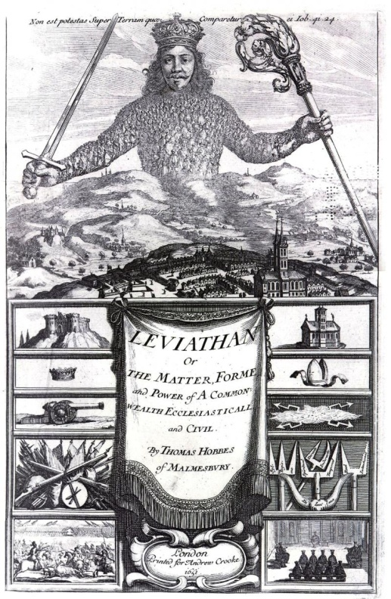
WIKIMEDIA
The frontispiece of the book Leviathan by Thomas Hobbes; engraving by Abraham Bosse, 1650.
Enlightenment political philosophers were united in their embrace of the new science and their opposition to the old order, but many parted ways with Hobbes’ enlightened absolutism, pushing instead for republican or democratic government with more expansive individual freedoms—in other words, the liberal democracy that most associate with the Enlightenment today. But it is important to bear in mind that the Western Enlightenment contained both absolutist and democratic strands.
Indeed, the century that followed Hobbes, the heyday of Enlightenment philosophy and science, is often known as the era of enlightened absolutism. Frederick the Great of Prussia, an ardent admirer and associate of the French Enlightenment philosopher Voltaire, set the pace, sponsoring modern science and applying its findings to agriculture, transportation, government, and (not least) war-making. Monarchs in Austria, Denmark, France, Russia, Spain, and Sweden, among others, followed Frederick’s example. These countries were far from democratic. Indeed, thanks in part to their ability to harness Enlightenment techniques for state organization, their rulers enjoyed much more power than their medieval counterparts ever did.
It wasn’t until the revolutions of the late eighteenth century in North America, France, the Netherlands, and Poland (ruled by Russia and Prussia) that enlightened absolutism gave way to the alternative republican or democratic strand of the Enlightenment. But that transition itself entailed catastrophic violence within and among states. As the historian R. R. Palmer has written, the republican revolutions began as an aristocratic reaction against monarchs and the war debts they had accumulated on the back of the new technology. As landed elites began to assert their old rights and privileges, impoverished common people turned on their enlightened despots. (Neither the king of England nor the Dutch stadtholder qualified as an enlightened absolutist, but even they were following the general trend toward centralizing power.) European monarchs turned on the Enlightenment once the French Revolution inspired rebellion throughout the continent, which spiraled into terror and foreign wars in 1792–93. Out of those traumas emerged Napoleon, the Enlightenment on horseback, whose struggle against Europe’s monarchs—now zealous converts to traditionalism—thrust Europe into the longest and most destructive wars it had seen in 150 years.
Napoleon’s aggressive Enlightenment Empire brings us to the Islamic world. For it was Napoleon who, with his invasion of Ottoman-ruled Egypt in 1798, first brought the modern Enlightenment into the Muslim world. Napoleon introduced the printing press and founded an academy of sciences (the Institut d’Égypte, which was severely damaged during the popular uprising of 2011). Here, the phrase “modern Enlightenment” is key; during the Middle Ages, Islamic philosophers had already spearheaded a quite different enlightenment by introducing ancient Greek philosophy and science into Islamic tradition. By way of Muslim-ruled Spain, this medieval rationalism profoundly influenced Christian and Jewish thought for centuries to come. But that original Islamic Enlightenment had lain dormant for centuries by the time Bonaparte arrived.
In the wake of Napoleon’s withdrawal in 1801, the Ottoman Empire proved unable to reestablish control and, under the strong 43-year rule of Muhammad Ali, Egypt began a process of modernization. In the nineteenth century, many Ottoman elites—soldiers, bureaucrats, educators—likewise found the principles of modern practical learning appealing, even though those principles had come from the same Europe that was humiliating their once-mighty empire. By the end of the century, the Young Turks saw traditional Islam’s domination of law, state, and learning as the primary source of Muslim weakness, and the adoption of Enlightenment technology, beliefs, and practices as the surest route to ending their humiliation. A decisive moment came in 1924, when Mustafa Kemal Ataturk dissolved the Ottoman caliphate, founded the Republic of Turkey, and put the secular state decisively in charge of religion. “We do not consider our principles as dogmas contained in books that are said to come from heaven. We derive our inspiration not from heaven, or from an unseen world, but directly from life,” Ataturk said in 1937. His words would have pleased Thomas Hobbes.
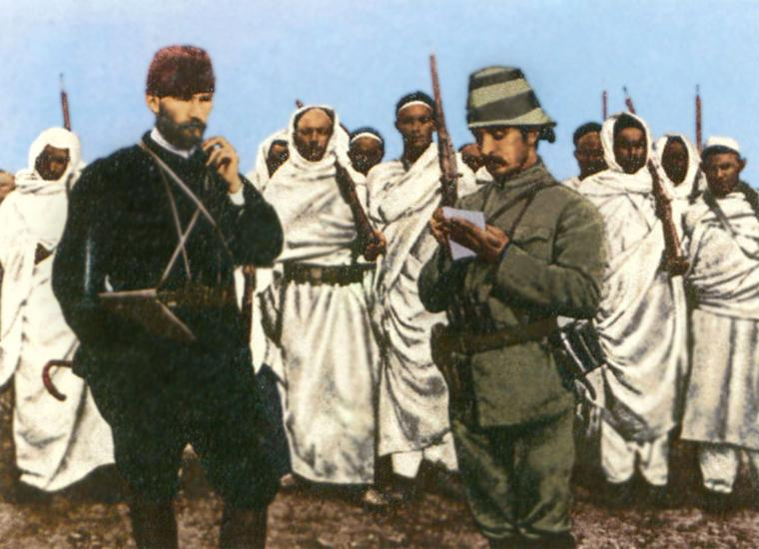
WIKIMEDIA
Mustafa Kemal Bey (Ataturk) with an Ottoman military officer and Bedouin forces in Derna, Tripolitania Vilayet, 1912.
As Frederick the Great had done in eighteenth-century Europe, Atatürk inspired imitators in the Muslim world: Reza Shah in Iran, Muhammad Ali Jinnah in Pakistan, Gamal Abdel Nasser in Egypt, the Baathists in Syria and Iraq. These were no backward-looking traditionalists. They were forward-looking state builders seeking to apply modern rationality and science to society. But like the enlightened absolutists of eighteenth-century Europe, twentieth-century secular Muslim rulers were power-seekers. The Ataturks and Nassers needed to improve the lot of the common people in order to win them over and weaken the authority of traditional religious teaching and institutions. They were authoritarian not in spite of Enlightenment influence but because of it.

Much has happened in the Middle East since the heady days of mid-twentieth-century secularism. Traditional Islam never went away, and it continued to be used to back monarchical rule in Saudi Arabia and elsewhere. It evolved into modern Islamism, in all its variety, and established regimes in Iran and Sudan. Secular regimes in Egypt, Syria, Iraq, Pakistan, and elsewhere found that they had to Islamicize to varying degrees just to maintain their legitimacy.
There is no question that, today, Islamism is resurgent, with a radicalized wing growing in militancy and brutality. But Westerners should not be fooled by the strength of Islamism into thinking that the Muslim world simply needs a modern enlightenment. The violence that continues to shake so many Muslim societies is in part about Islam’s ongoing confrontation with an enlightenment imposed on Muslim societies from above, much as European absolute monarchs imposed the young Western Enlightenment on their societies centuries ago. Whatever the future may hold for an Islamic enlightenment, we should understand that, like its Western precursor, its progress is bound to be violent precisely because it is both a spiritual and a political project that is bound to generate both religious and political reactions. Indeed, if we want to see what the early phases of the West’s own Enlightenment looked like, we could do worse than to look at today’s Middle East.
Muslims have encountered post-Enlightenment Western society in myriad ways for a long time, and they are torn among themselves in reaction. Today’s Islamists, whose reaction understandably preoccupies us, do not live in a historical bubble. Indeed, more than a few of those rallying to the cause spent their formative years in Western societies and were educated in Western schools. They have seen the West’s version of the future and do not believe that it works. Not only, then, does the West’s past help us understand Islamism today, Islam’s present is also instructive about where the West finds itself in the long, turbulent, and still ongoing history of its own Enlightenment.
Follow-up tasks:
- Discuss the era of Enlightenment in Europe. What features did it introduce?

- What role did Napoleon play in bringing “enlightenment” to the Middle East?

- Who were/have been some of the leading enlightened despots in both Europe and the Middle East? Try to briefly characterize each of them and their actions.

