A Brief history of the imbalance of power in the Middle East
Summary
There is no way to explain the Middle East simply. Entangled in this troubled region are ancient ethnic rivalries, religious vendettas and cultural divides, somehow made worse by their present-day boundaries, that defy generalization. But it’s impossible to explain the Middle East without explaining the competition between Arabs – now led by Sunni-majority Saudi Arabia – and Persians – now led by Shiite-majority Iran. This competition is religious, too, considering it began shortly after the dawn of Islam. Since then, the Arabs have had their fair share of power but, to their chagrin, have struggled to assimilate or subdue the Persians. Even now, Persian influence is on the rise at a particularly vulnerable time for the Arabs.
Consider, then, Muqtada al-Sadr’s recent visit to Saudi Arabia. The Iraqi Shiite leader met with Saudi Crown Prince Mohammed bin Salman, the heir apparent to the Saudi kingdom and, therefore, the next steward of Sunni Islam’s most holy sites. Consider, too, his meeting with Emirati leader Sheikh Mohammed bin Zayed on Aug. 13. Is it merely a coincidence that a maverick such as al-Sadr would visit Sunni powers now, of all times? What does that say about Shiite influence?
This question can be answered partly by the plight of the Sunni Arabs, who, bereft of unity and reliable political leadership, now populate feckless if not broken states throughout the region. The following report shows how these kinds of struggles have been a near-permanent fixture in the Middle East since the dawn of Islam – and how they have shaped the modern Middle East.
The Rise of the Arabs
Before Islam, Arabs were confined largely to the Arabian Peninsula. They were nomads, warring and leaderless. To the north of the peninsula lay the Byzantine Empire. Across the Persian Gulf lay the Sassanid Empire, which stretched from Mesopotamia to the South Caucasus. The two empires had fought each other intermittently for more than three centuries. It was under these circumstances that their fortunes changed as Islam emerged and became the founding philosophy of a new government in Medina. Ten years later, when the Prophet Muhammad died and a new leader replaced him – ushering in the first Arab empire, known as the Rashidun Caliphate – Arab Muslims had assumed control of the entire Arabian Peninsula.
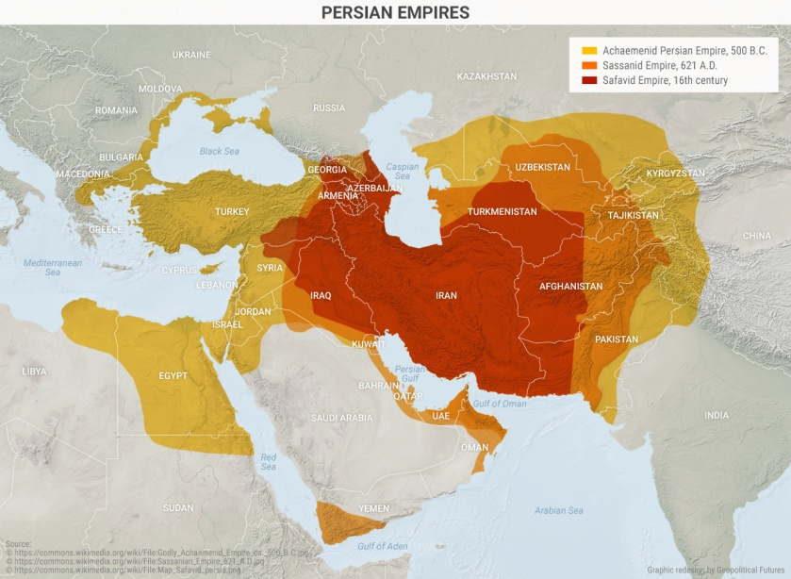
During the Rashidun Caliphate (632-661), the Arab frontier would spread into lands once controlled by the Byzantines and the Sassanids. The Byzantine Empire would stay intact, despite territorial losses, for another eight centuries. The Sassanid Empire, however, collapsed in 650, after the Arab invasion of modern-day Iraq and Iran.
The Arabs conquered the Sassanid heartland but they didn’t completely absorb the Persians whose lands they now controlled. Instead, the Arabs and the Persians pollinated each other with certain aspects of their respective cultures, making Persians “Islamic” and making Islam “more Persian.”
The Persian Revival
But the Arabs embraced Persian culture faster than the Persians converted to Islam. The Rashidun Caliphate adopted many administrative practices of the Sassanid Empire, including government structures, policy processes, taxation and coinage. Its successor, the Umayyad Caliphate (661-749), boasted several Persian provincial governors. Persian was the official business language until Arabic replaced it near the end of the 7th century.
When the Abbasids ousted the Umayyads and took over the caliphate in 749, they moved the capital from Damascus to Baghdad – deep in the heart of Persia. Unsurprisingly, the “Persianization” of Islam accelerated during this time. The Persian language had adopted the Arabic script but had begun to grow more popular. Persians became scientists, philosophers and religious scholars, and began to enter the ranks of the military and the bureaucracy, which had been monopolized by Arabs.
So great was the Persians’ influence that when Islam spread to Central Asia, the Turkic people who lived there converted to the Persianized version of Islam. Stunningly, the traditions of Persian subjects were adopted by Arab overlords – and not the other way around.
The Arabs assimilated at their own peril, however. By the 9th century, the Abbasid Caliphate began to dissolve into various Persian and Turkic principalities. Control of the Abbasid regime was relegated to an area in Mesopotamia that did not extend much beyond Baghdad. Many principalities were still Sunni but were in practice dominated by Persian elite. They included the Saffarids (based in the border region of modern-day Iran and Afghanistan), the Tahirids (based in northwestern Iran) and the Samanids (based in present-day Central Asia). Many Arab Shiites, in fact, broke off from the Abbasids as well, forming independent groupings in Iraq and Syria, Morocco and Egypt.
One such grouping known as the Buyids posed the biggest threat to the Abbasids but was defeated in the mid-11th century by the Seljuk Turks, who had grown quite powerful under the Arab empire. Meanwhile, the Fatimids, a Shiite Ismaili dynasty, created a rival caliphate in North Africa, eventually controlling large portions of the Levant and the coastlines of the Red Sea.
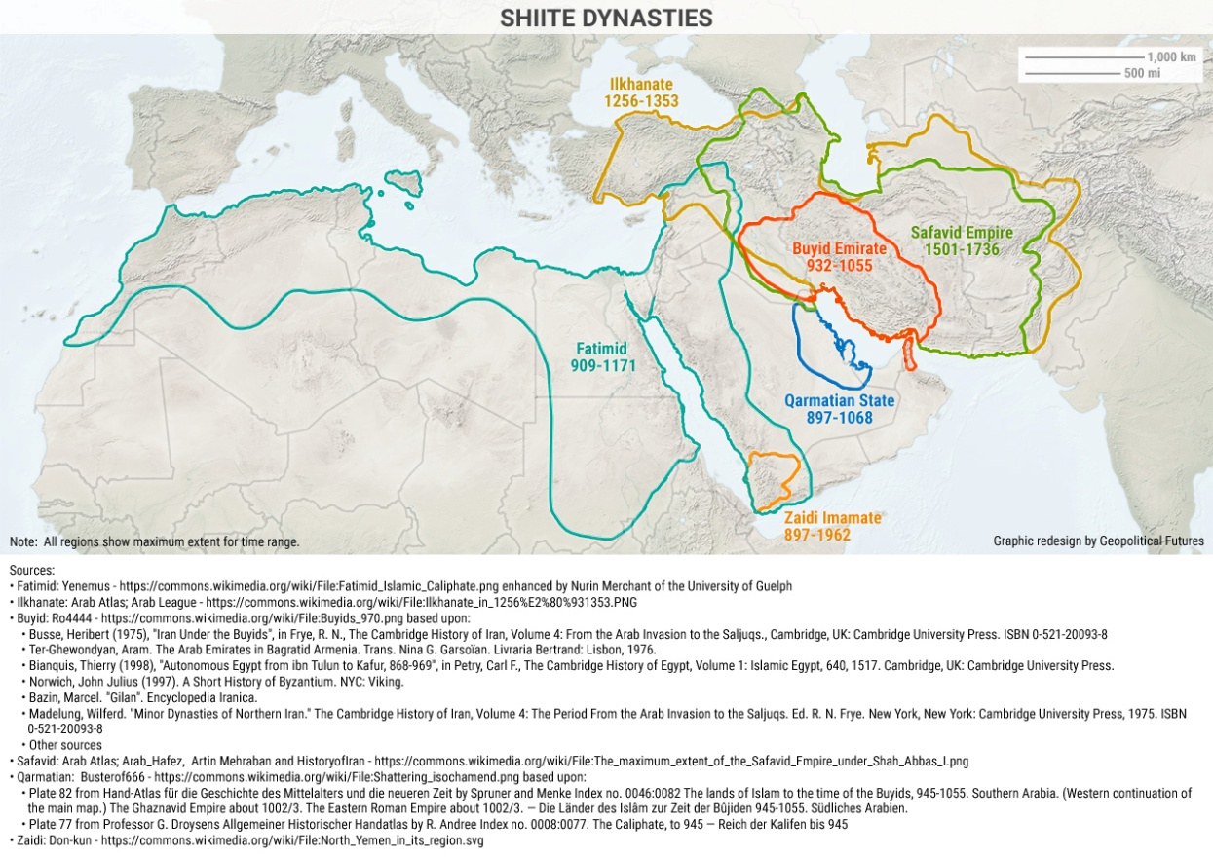
By the 13th century, the Mongols destroyed what remained of the Abbasid Caliphate and assumed control of the Persian portion of the Muslim world. Eventually the Mongols converted to Islam and established what were ethnically Turkic but otherwise Persianate regimes, including the Ilkhanids (1256-1353) and the Timurids (1370-1507). The Turkic forces eventually focused on areas to the west, east and north of the Persian heartland, which allowed the Persians to stage a comeback.
The Persian revival came in the form of the Safavid Empire (1501-1736). The Safavids laid the foundations of modern Iran. They adopted Shiite Islam as the official state religion, and they restored Persian sovereignty over the lands of their forebears. The Safavids at their peak controlled all of modern-day Iran, Azerbaijan and Armenia and parts of Afghanistan, Pakistan, Turkmenistan, Uzbekistan, Turkey, Syria, Georgia and Dagestan. Rivals of the Ottoman Empire to the west and the Mughal Empire to the east, the Safavids were later succeeded by the Qajar Dynasty (1795-1925), which began courtships with Russia and the United Kingdom. After the Qajars came the Pahlavis, who would rule Iran until 1979, when they were overthrown during the Iranian Revolution.
In a sense, the Arabs never recovered from the fall of the Umayyads and the Persianization of the Abbasid Caliphate. The Arabs under the leadership of the remnants of the Umayyads controlled lands outside the Arab world, on the Iberian Peninsula, until 1492. Territories in the Middle East fell to Persian and Turkic dynasties. The Ottoman Empire gained control of much of the rest of the Middle East in the 16th century and held it until the end of World War I, after which it was administered by the British and the French. There were some notable exceptions in this admittedly long period of time, but the Arab regimes that did hold sway, including the Fatimids (909-1171), the Zaidis (897-1962) and the Qarmatians (897-1068), were not Sunni. Others such as the Ayyubids (1171-1260) and the Mamluks (1250-1517) were Sunni but were Kurdish and Turkic.
The Modern Era
The states created after World War I were, however poorly conceived by their colonial cartographers, Arab. But the regimes that governed them – leftist secular republics or traditional monarchies – were weak, and as such were never able to create viable political economies. Their failings in the Cold War era and the wars with Israel attest to their weakness.
The modern Middle East has been trying (and failing) to find its footing. The 1991 Gulf War threw the region into chaos. Secular-Islamist divides have grown as deep as ever. Islamism itself is highly fragmented, with jihadist movements, most notably the Islamic State, competing with one another for primacy.
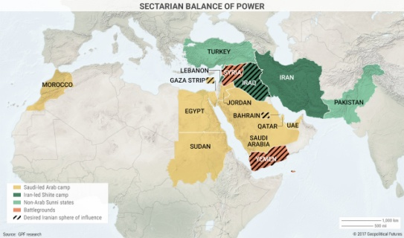

This explains why, since the Arab Spring, we have seen the meltdown of the Arab countries that grew out of the Ottoman Empire. Countries like Iraq, Syria, Yemen and Libya are shattered beyond repair. The largest Arab state, Egypt, which only a few decades ago was an emerging leader in the region, now depends on its one-time rival, Saudi Arabia, as well as energy-rich Gulf nations and international lending agencies, to remain financially afloat. The burden of propping the region up has fallen on the shoulders of Saudi Arabia, which, despite its oil wealth, remains a weak state incapable of guaranteeing regional security and stability, especially with oil prices as low as they are and will continue to be.
In fact, the Saudis can’t even impose their will on a tiny fellow Arab state like Qatar, as the dispute between the two countries shows. Qatar has resisted the kingdom, demonstrating that it lacks confidence in Saudi Arabia’s ability to lead the region. Meanwhile, jihadist groups such as the Islamic State and al-Qaida continue to challenge the kingdom for leadership over Riyadh’s founding ideology, Salafism. Not only is Saudi Arabia weakening, but the region’s problems are getting bigger.
As the Arab world descends into anarchy, things are looking up for Iran. This is a frightening scenario for the Saudis. Though far from ideal, Tehran has negotiated a deal with the United States that has provided it respite from the sanctions regime. Its Arab Shiite allies have the upper hand in Iraq, Syria and Lebanon. Other Shiite arenas, such as Yemen, Bahrain and even the Eastern Province of Saudi Arabia, also seem promising from Iran’s point of view.
The collapse of the Arab world’s autocracies has created space for jihadists and other Islamist actors, as well as non-Arab actors, to maneuver. Iran is not without its limits, but it will continue to take advantage of the emerging opportunities in the Arab world, which can no longer rely on the U.S. to provide for its security. If the Arabs want to limit the extent to which the Persians can spread their influence in the region, they’ll have to turn to another outsider: the Turks.
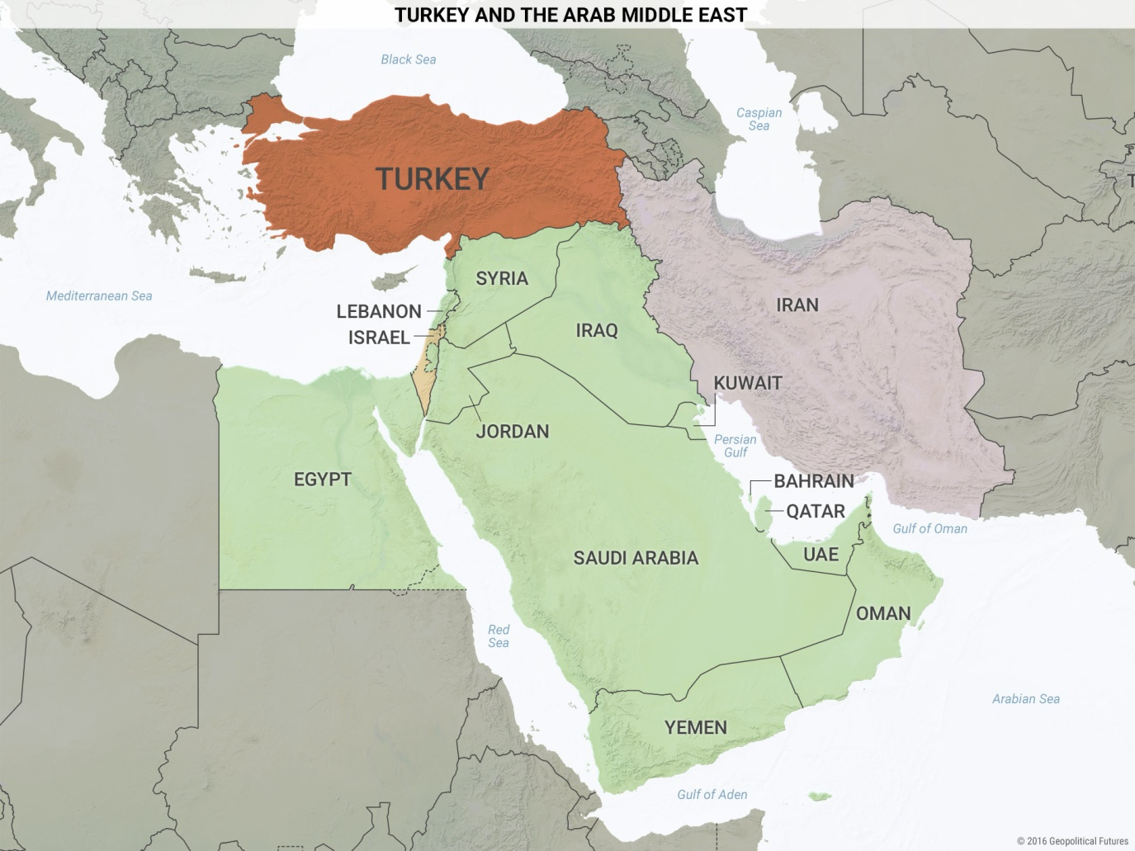
The Arabs emerged out of the Arabian Peninsula, which has been geopolitically significant only on two occasions in history: during the rise of Islam in the 7th century and the discovery of oil in the 20th century. In the intervening centuries, Arab power had been highly limited. Perhaps the Arab world is regressing to the historical mean.

Follow-up tasks:
1. Try to summarize the paragraphs titled: The Rise of the Arabs, the Persian Revival and the Modern Era
2. What role have the Western powers played in shaping the region?
3. What current issues does the region face, especially in relation to Europe?

Source: Shapiro, J. Geopolitics 101. https://geopoliticalfutures.com/brief-history-imbalance-power-middle-east/, last update August 17, 2017.

