This Is the Moment That Decides the Future of the Middle East

If the United States is done fighting for Saudi Arabia’s oil, it's done fighting for the entire region.
BY STEVEN A. COOK
SEPTEMBER 17, 2019, 9:48 AM
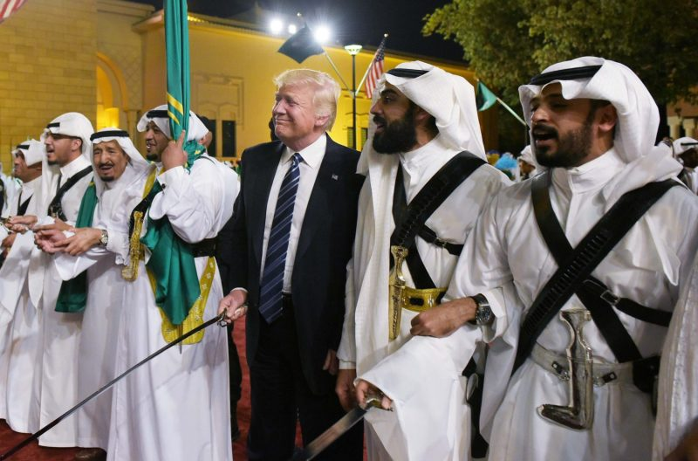
President Donald Trump joins dancers with swords at a welcome ceremony ahead of a banquet at the Murabba Palace in Riyadh on May 20, 2017
Since the end of World War II, three core interests have shaped U.S. Middle East policy: ensuring the free flow of energy resources from the region, helping to maintain Israeli security, and making sure no state or group of states can challenge American power in a way that would put the other two interests at risk. In other words, aside from the strategic, historical, moral, and political reasons for the “special” U.S.-Israel relationship, oil is the reason why the United States is in the Middle East at all.
That’s why this moment—the aftermath of an attack on Saudi Arabia’s most significant crude-oil processing facilities—is so important. How the Trump administration responds will indicate whether U.S. elites still consider energy resources a core national interest and whether the United States truly is on its way out of the Middle East entirely, as so many in the region suspect.
When the story broke on Saturday morning that Saudi Arabia’s processing facilities at Abqaiq and Khurais were attacked and that the likely culprits were Houthis, the debate among foreign-policy experts quickly became about Saudi Arabia’s culpability for suffering in Yemen, how much influence Iran has with the Houthis, and whom the Saudis were actually fighting. These questions only intensified after U.S. Secretary of State Mike Pompeo specifically accused Iran of the attacks. Speculation was that Pompeo—an Iran hawk—was being too cute by half, directly blaming the Iranians though Tehran was likely only indirectly responsible. This is not an unreasonable position, given Iran’s long history of avoiding direct confrontation in favor of supplying proxies with money, technology, and weapons to do their dirty work around the region. Others agreed with Pompeo that the Iranian role was clear, a position that grew stronger as reports surfaced that cruise missiles were used in the attacks. It was a robust, if not always edifying discussion. It also does not really matter.
Going back to U.S. President Franklin D. Roosevelt’s encounter with Saudi King Abdulaziz early in 1945, the United States has pursued policies to ensure that oil exports from the Middle East are unimpeded. Operation Desert Storm in 1991 was simultaneously not a “war for oil” and a war fought to protect the free flow of oil. As U.S. President George H.W. Bush made clear at the time, there were certain principles involved in the decision to deploy 540,000 Americans to Saudi Arabia and then use force to push Iraqi President Saddam Hussein from Kuwait, notably that it was an egregious violation of international norms for one country to swallow up another. The precedent that Saddam would set was just too dangerous. It was an appropriate justification, but the violation of international norms also threatened core American interests. Had he gotten away with it, Saddam would likely have been emboldened to threaten Israel, menace Saudi Arabia and others—potentially disrupting oil supplies,—and in the process challenge American hegemony. This is why just three days after Iraqi tanks rolled over Kuwait City in the summer of 1990, Bush declared, “This will not stand, this aggression against Kuwait.”
It is not just at moments of crisis that the United States has sought to ensure that the oil spigot remains open. Its entire approach to the region, from routine business of diplomacy to high-stakes affairs such as maintaining “dual containment” and even negotiating the Joint Comprehensive Plan of Action, has been geared toward making it safe for tankers to pass through the Strait of Hormuz.
Policymakers in Washington have long been obliged to make peace with their country’s strategic relations with generals, kings, and presidents who abuse their own people, make a mockery of values American hold dear, and demand that the United States provide them with security—all because of oil. At the G-7 summit in Biarritz, France, in August, U.S. President Donald Trump referred to Egypt’s leader, Abdel Fattah al-Sisi, as his “favorite dictator.” But the president’s personal fondness—however embarrassing it may be—isn’t what’s driving the relationship. Egypt and the Suez Canal are important parts of a U.S.-led regional order that helps the United States pursue its interests, especially the free flow of energy resources.
The importance of oil to the United States may very well change as technology advances to make alternative energy, electric vehicles, and battery storage better and cheaper. In the meantime, Middle Eastern energy resources remain a core interest. American and global prosperity (which are inextricably linked) remain carbon-based, which is why it has been so odd that the Trump administration has been so passive in response to threats to this core interest.
Events in the Persian Gulf have demonstrated to Iran’s leaders that they can escalate with impunity. During the spring and summer, Iran’s Islamic Revolutionary Guard Corps (IRGC) began by placing mines on tankers, then shooting down an American drone, and followed up with the disruption of tanker traffic in the Strait of Hormuz. The Trump administration’s response to this was generally weak, establishing a new maritime security mission with allies and applying sanctions to Iranians who will never travel to the United States and do not hold assets there. Now, if the secretary of state is to be believed, the Iranians struck critical nodes in Saudi Arabia’s oil infrastructure, taking significant amounts of crude off the global market. This is what happens when you signal to the IRGC that they own the Persian Gulf.
The Iranians—and other opponents of the United States in the region—have every reason to believe that Trump speaks loudly and carries a nonexistent stick. No one wants war, but it is plausible that had the United States retaliated after Iran shot down an American drone, the Iranians might have thought twice about taking a major step like attacking Abqaiq and Khurais. Of course, no policy is risk-free and the dangers of a wider regional conflict are everywhere, but the Iranians (if they were behind the attacks) are testing the entire rationale for U.S. investment in the Middle East over the last 70 years. If Trump does not respond militarily, the United States should just pack up and go home.
Available at: https://foreignpolicy.com/2019/09/17/this-is-the-moment-that-decides-the-future-of-the-middle-east/

