Why does Multiculturalism Work in Canada?
From reading news headlines during the past three years in the United States and Europe, it appears that for the most part, multiculturalism hasn’t lived up to its expectations.
Even worse, it’s been blamed for accelerating the rise of ethnic nationalism and far-right movements on both sides of the Atlantic.
In the midst of this tempest, Canada remains a relative oasis of calm, free of the racial and ethnic tensions (and violence) witnessed in America and in Europe.
So why does multiculturalism work in the Great White North? What has Canada done right in implementing its policy of multiculturalism?

A Brief History
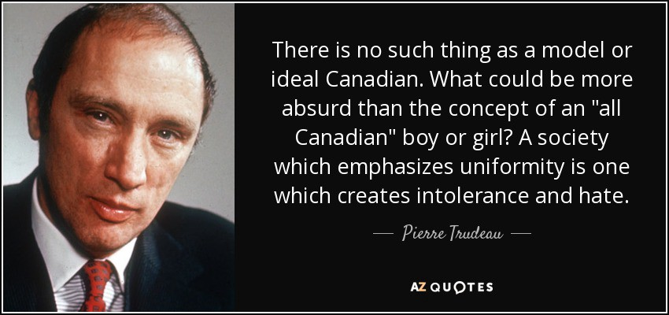
Multiculturalism became official Canadian policy under the government of the late Pierre Elliot Trudeau (Justin’s father) in 1971. In doing so, Canada was the first country in the world to adopt multiculturalism as official policy.
What “multiculturalism” means in the Canadian context is that:
Canadian multiculturalism is fundamental to our belief that all citizens are equal. Multiculturalism ensures that all citizens can keep their identities, can take pride in their ancestry and have a sense of belonging. Acceptance gives Canadians a feeling of security and self-confidence, making them more open to, and accepting of, diverse cultures. The Canadian experience has shown that multiculturalism encourages racial and ethnic harmony and cross-cultural understanding.
Mutual respect helps develop common attitudes. New Canadians, no less than other Canadians, respect the political and legal process, and want to address issues by legal and constitutional means.
Through multiculturalism, Canada recognizes the potential of all Canadians, encouraging them to integrate into their society and take an active part in its social, cultural, economic and political affairs.
This policy was implemented to counter the Quebec separatist movement which had reached its apex one year earlier in 1970. To the uninitiated, Quebec is the French speaking province in Canada, founded by ethnic French settlers in 1608. It remained French territory until the French were defeated by the British in 1759, leading to the surrender of Quebec to the British.
Quebec eventually became one of many Canadian provinces, but the resentment by the French speaking peoples of Quebec against “English Canada” had always simmered just beneath the surface, and this eventually led to the Quebec sovereignty movement.
During October 1970, a Marxist/Leninist paramilitary group named the Front de libération du Quebec, had kidnapped Quebec cabinet minister Pierre LaPorte and British diplomat James Cross in the Montreal metropolitan area. They had eventually murdered Laporte, but released Cross after negotiations led to his release and the kidnappers’ exile to Cuba.
In this context, the primary impetus for Canada’s multiculturalism policy was to combat ethnic nationalism.
The concept of multiculturalism was again acknowledged in the Canadian Charter of Rights and Freedoms of 1982, which states that the Charter itself “shall be interpreted in a manner consistent with the preservation and enhancement of the multicultural heritage of Canadians.”
On 21 July 1988, the Progressive Conservative government of Brian Mulroney passed the Canadian Multiculturalism Act, which formalized the government’s commitment to “promote the full and equitable participation of individuals and communities of all origins in the continuing evolution and shaping of all aspects of Canadian society” by establishing legislation to protect ethnic, racial, linguistic and religious diversity within Canadian society.

A Key Factor for Success: Canada’s Immigration Policy
Canada’s immigration policy sets out to attract the best skilled workers from around the globe. As such, Canada gives skilled immigrants priority to receive permanent residency, based on criteria such as their age, work experience, language ability, education and much more.
They list these attributes in the application system and federal workers review their profiles and rank them based on an applicant’s chance of economic success and integration. Ranking is done with a Comprehensive Ranking System, a points based system. Canada has had a points based system since 1967.
The system awards the most points to those it considers the best candidates. People get points if they already have a job offer. They can also rack up points depending on how well they speak English and French, whether or not they are young, and whether or not they have work experience in a high-demand field. Potential immigrants with high rankings are invited to apply for permanent residency. Upon obtaining permanent residency, he or she can sponsor a spouse and children to immigrant to Canada.
Now when the Canadian economy requires workers that don’t meet eligibility criteria for permanent residency (fruit pickers, janitors, factory workers) both business and government draw upon the services of “temporary workers”, who come to Canada under its Temporary Foreign Worker Program. Most workers under this program are limited to working in Canada for four years before having to return to their home country. They do however, have the opportunity to apply for permanent residency status should they choose to do so.
I cannot emphasize enough how important a merit-based immigration system has been to the success of multiculturalism in Canada: it protects the wages of those at the bottom of Canadian society who don’t have to compete with the global labour market and suffer the destructive race to the bottom.
In contrast, uncontrolled immigration in the United States and Europe has negatively impacted the most economically vulnerable members of those societies. This has made them susceptible to the appeals of far-right ethnic nationalists, whose political movements promise them jobs and economic security.

A Model for the World
Canada’s success in integrating disparate peoples from around the globe through its policies and immigration system has been held up as a model for the world. Australia’s own point-based system, formalized in 1989, was modelled on Canada’s. And like Canada, Australia has become a de facto multicultural society.
More recently, several Scandinavian countries have emulated Canada’s immigration and integration policies to deal with social problems within immigrant communities. It has been held up as an alternative to humanitarian and family migrants, which has contributed to a significant immigrant-native employment gap in Scandinavia.
Finally, the Trump administration has expressed great interest in reforming its immigration system to emulate Canada’s, giving priority to skilled workers.
Source: Fong, V.: 2018. Why does multiculturalism work in Canada? Medium. Available at: https://medium.com/the-torontonian/why-does-multiculturalism-work-in-canada-d52ac4e23747.

Follow-up tasks:
1. Try to characterize multiculturalism in your own words. Which European countries have also struggled with it?
2. What makes Canada so unique and why does multiculturalism somehow work there?

For Glenn Gould, Form Followed Fingers
EVEN to his most passionate admirers, the phenomenally gifted if wildly unconventional pianist Glenn Gould was a tangle of personal tics and complexes. Sometimes he seemed a provocateur bent on riling the public with extreme interpretations and odd behavior. Other times he came across as a fragile, fearful man, at ease only when making music.
“Genius Within: The Inner Life of Glenn Gould,” the fascinating new documentary by the Canadian filmmakers Peter Raymont and Michèle Hozer, has won praise for providing insights into Gould’s eccentric character. It shows the sad progression of a brilliant, garrulous musician with a fiercely original artistic vision as he becomes increasingly obsessive and isolated. Yet it also provides valuable insights into the inner workings of Gould’s distinctive technique and unorthodox interpretive approach.
In his chosen repertory, especially Bach, Gould played with uncanny clarity and brought seemingly impossible independence to individual voices. Though Gould was drawn to Baroque music and instinctively cultivated lucid musical textures, the film reveals the extent to which his principal teacher, the Chilean-born pianist Alberto Guerrero, imparted skills that maximized clarity.
An only child, Gould studied piano with his mother until, at 11, he began lessons with Guerrero at the Toronto Conservatory. By the time he turned 20 he had set out on his own.
Guerrero was an advocate of a technical discipline known as finger tapping. Apparently, the idea came to him while watching a young boy dancing in a Chinese circus. Guerrero spoke to the boy’s trainer, who demonstrated his teaching routine: he moved the child’s passive limbs into the desired positions, which the boy would then replicate, trying to maintain the feeling of relaxation.
Adapting the technique to the piano, Guerrero taught his students to hold one hand in a relaxed position on the keyboard, lightly touching the keys. With the other hand, the student would tap a fingertip enough to depress the desired key. The mechanical action of the key springing up would lift the finger back into place. The idea was to teach the fingers to play with a minimum of effort and no excess lift. This practice routine is demonstrated in the film by Gould’s friend Ruth Watson Henderson, also a Guerrero student. Like Gould, Guerrero sat low to the ground, though not as low as Gould, whose preferred chair was just 13 inches high.
There are as many approaches to piano technique as there are to Major League pitching, including some that emphasize lifting the fingers off the keys. Guerrero’s regimen certainly worked for Gould, as is clear from the arresting segments in this documentary that show him close up, playing — Bach’s “Goldberg Variations,” Bach’s D minor Keyboard Concerto, Beethoven’s Second Piano Concerto live on tour in the Soviet Union in 1957 — always with pristine clarity and effortlessness, no matter how breathless the tempos.
Gould’s finger-oriented technique explains, in part, why he sat so low, though he was a gangly man. In this crouched posture, with his hands reaching up to the keyboard, his fingers do everything. Yet you cannot play the piano, at least the brawny works of Liszt and company, with just your fingers. Your arms, shoulders and back — even your feet (to provide support during fortissimo chords) — must get into act as well. There are techniques that teach pianists to drop loose arms, almost like dead weights, into thick chords, to let body mass fortify the sound.
That Gould’s astonishing playing lacked this bodily dimension comes through in the film, in a segment about his performance of Brahms’s D minor Concerto with Leonard Bernstein and the New York Philharmonic in 1962. Bernstein received criticism at the time for preperformance remarks to the audience in which he issued a disclaimer.
“You are about to hear a rather, shall we say, unorthodox performance of the Brahms D minor Concerto,” Bernstein began, “a performance distinctly different from any I’ve ever heard, or even dreamt of for that matter, in its remarkably broad tempi and its frequent departures from Brahms’s dynamic indications.”
Bernstein then spoke about collaboration. Usually, a conductor and a soloist with interpretive discrepancies manage to “get together by persuasion or charm or even threats to achieve a unified performance,” he said. But in this case the disagreements were so great, he explained, that he had to make clear he was deferring to Gould. He emphasized, though, that there “are moments in Mr. Gould’s performance that emerge with astonishing freshness and conviction.” (When you hear those comments today — in the film or on the Sony live recording — Bernstein comes across as tactful and sincere.)
The tempos in this performance are fairly broad. Yet 21 years later, Bernstein conducted a magnificent live performance of the Brahms D minor with a pianist he loved working with, Krystian Zimerman, and the Vienna Philharmonic (available on CD and DVD from Deutsche Grammophon). That one clocks in only slightly longer (just over 54 minutes) than the Gould-Bernstein account (just over 53)
Mr. Gould in a photograph that shows his unusual posture at the piano. His technique, much of it imparted by his teacher Alberto Guerrero, was finger- rather than body-driven Credit Don Hunstein/Sony
In retrospect Bernstein must have been bothered by Gould’s other “departures” more than by the slow tempos. As Gould recalled in a radio interview in 1963, he was swept up with Baroque music at the time of the Brahms performance and trying to flesh out Baroque elements in Brahms. It is not the slowness that seems strange, or anti-Romantic, but the deliberate pulse, the detached articulation and the constricted range of dynamics. Brahms often wrote for the piano as if it were an orchestra. Here Gould tried to rid the piano part of orchestral thickness and purge the music of blatant expressive contrasts.
The performance received some outraged reviews. Harold C. Schonberg in The New York Times, though highly critical, took a humorous approach. The review is written as a mock letter to a fictional friend, Ossip. (A stand-in for the old-world Russian Romantic pianist Ossip Gabrilowitsch?) Schonberg took particular heat for a sentence in which he suggested that Gould had played the concerto so slowly because “maybe his technique is not so good.” That gibe might have been too sweeping, but Schonberg had a point.
It takes the whole body to play the Brahms concerto. You cannot dispatch this thick, chord-strewn work with fingers alone. During the development section of the first movement, as an outburst of rising octaves in the right hand races up the keyboard, chased by an outburst in the left hand, Gould’s playing sounds anything but effortless. He gets through it, but not easily.
Louder
Stay on top of the latest in pop and jazz with reviews, interviews, podcasts and more from The New York Times music critics.

You agree to receive occasional updates and special offers for The New York Times's products and services.

Gould’s performance has moments of stunning beauty and integrity, as when it brings out inner voices with remarkable clarity. The film quotes Gould from a radio interview the next year saying he found Bernstein’s speech that night full of good spirit and thought the whole controversy was amusing.
That Gould was beloved by a circle of intimates comes through touchingly in the film, especially in an interview with the audio engineer Lorne Tulk. After Gould, at 31, stopped giving public concerts and confined his work to the recording studio, he spent countless hours with Mr. Tulk, who carried out his painstaking editing demands. Gould was a pioneer in the creative (some would say manipulative) use of recording technology. Mr. Tulk was sometimes so involved in Gould’s recording projects that he neglected his children, he says. Still, he was a devoted friend.
One day Gould told Mr. Tulk that they should be brothers, that they should actually go to some office in Toronto and make it legal. Mr. Tulk, as he recalls in the film, gently answered, “I would love to be your brother, Glenn,” but “I have four brothers and a sister” who might want some say in the matter.
Gould thought this answer was very sweet, Mr. Tulk says. The subject never came up again.

Source: Tommasini, A.: 2010. For Glenn Gould, Form Followed Fingers. The New York Times. Available at: https://www.nytimes.com/2010/09/26/arts/music/26gould.html.
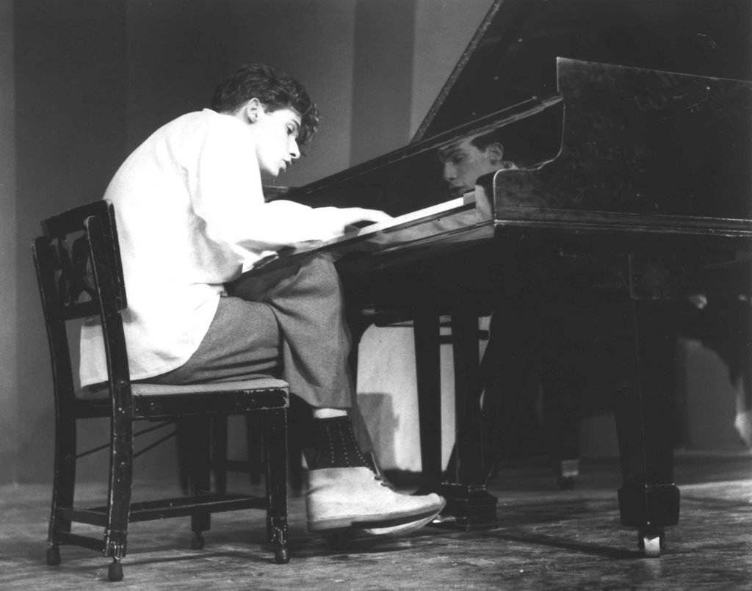
Follow-up tasks:
1. What made Gould so special as a pianist? What were his “quirks”?
2. Why were the critics disillusioned by him?
3. Can you think of other artists and their weird habits? Why do you think that is oftentimes the case?

